Project introduction

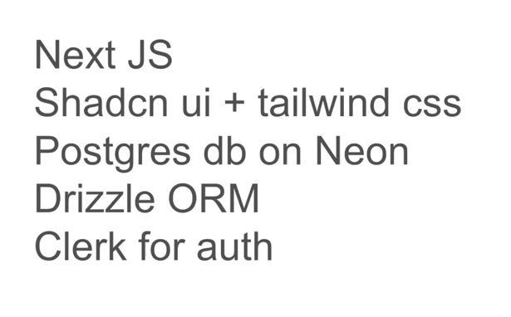

Different layer of architecture.
Many different coding standards.
The whole point of the project to understand the different layer of project.
15. Setup up Next JS project
npx create-next-app@latest linkshortenerproject
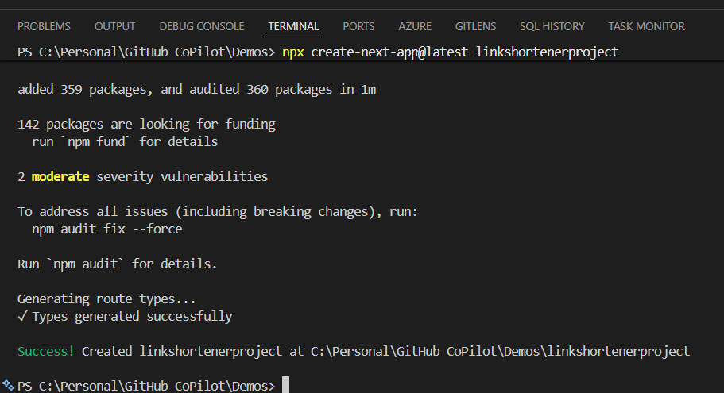

https://ui.shadcn.com/docs/installation
npx shadcn@latest init

neon.com
add Project
-> LinkshortnerProject
-> Choose the Database
-> Postgres DB
-> Default version
->Choose the location to keep database

https://orm.drizzle.team/docs/get-started/neon-new
Getting Strated
- Neon
- npm i drizzle-orm @neondatabase/serverless dotenv
- npm i -D drizzle-kit tsx

Create .env file
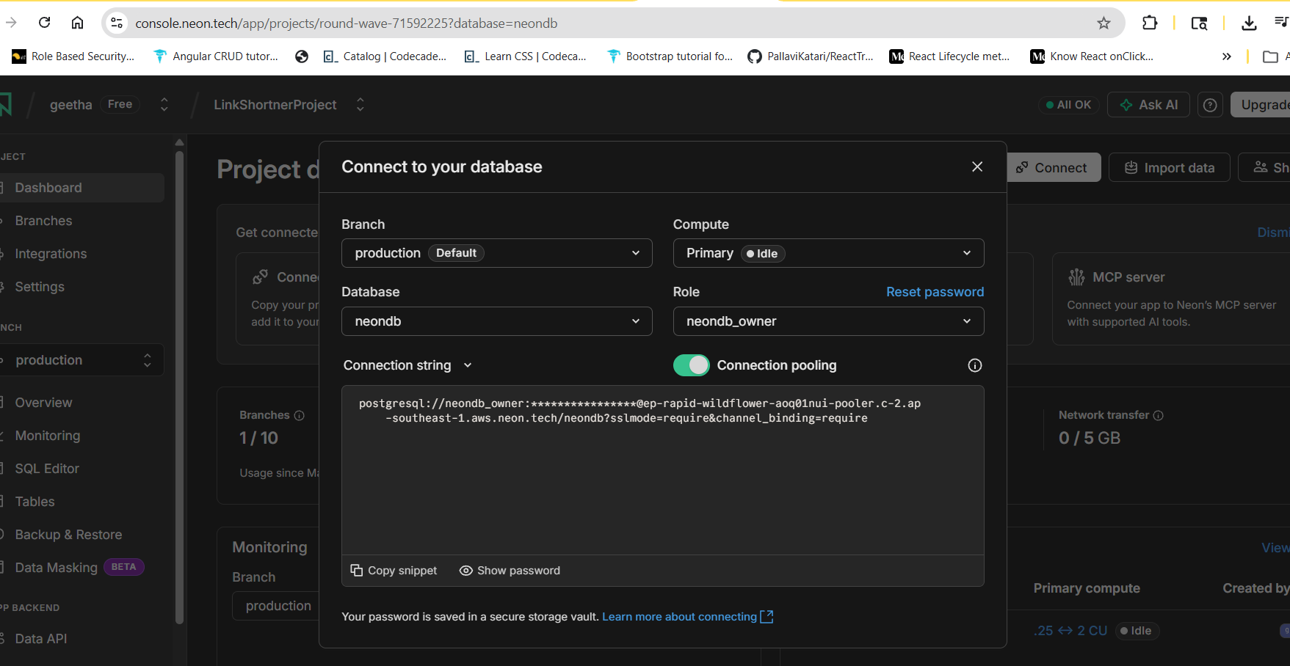
Paste the connection copy snippet
[agent mode]:
[copy and paste prompt from clerk]

